Covariance Matrices

of

VELA Beam Distributions

Duncan Scott

ASTeC: Accelerator Physics Group

February 2015

**Abstract**

Covariance matrices of VELA beam distribution, found directly from the data or by fitting, are presented for various BSOL, Q1, Q2 and Q3 settings for data taken on Dec 12 2014, shift 210. Approximately 7000 images are in the data set, and there is a good agreement between fitting and direct calculation of the matrix elements, although some images are saturated giving less believable results. There are a few unexplained features that could be due to machine drifts, analysis effects or poor data acquisition, e.g. hysteresis effects in the quadrupoles. These features are not too significant, and will be subject to further study. This data can now be used to fit a model of the accelerator to obtain values for the emittances and lattice functions.

# Introduction

Two methods have been used, ***fitting*** a Bivariate Normal Distribution and ***directly*** ***calculating*** the covariance matrix of distribution. The basic methods were described here [[1]], where pre-processing the raw images was also discussed. In outline the pre-processing procedure is:

* Subtract background (no beam) images to reduce dark current
* Cut the camera image to the screen using an elliptical mask
* Fit Normal distributions to the projections
* Use 1D fits to cut the data to twice the full width half maximum in x and y, centred on the peak
* If fitting: remove any saturated points

# Fitting a BVN

Once the raw camera images have been pre-processed we fit a Bivariate Normal Distribution (BVN). This is entirely characterised by its first and second moments, or a covariance matrix. The covariance matrix of the beam distribution is a linear transformation of an identity matrix: with variances and standard deviations equal to 1 and 0 covariance. This transformation can be represented by the sample mean vectorand a covariance () matrix comprised of the variances, and the covariance, and :

,

we assume , giving 5 independent fitting parameters. The fitting described previously expressed the BVN explicitly in terms of the minor and major axes of the ellipse, rotation angles, or equivalently the cross-correlation in the covariance, These descriptions are all equivalent giving a nice physical interpretation of the distribution. The next phase in the analysis is to fit the beam covariance matrix, to the accelerator model where it is not necessary to use more physically intuitive parameters. These parameters can still be recovered, e.g. rotation angles can be found by using on the components of the eigenvectors of the matrix, taking care to use in the correct quadrant. In practise two more parameters are included to scale the amplitude and add a constant background, giving the probability density for a vector as:

.

An example of some raw data and a fit are shown in Figure 1.

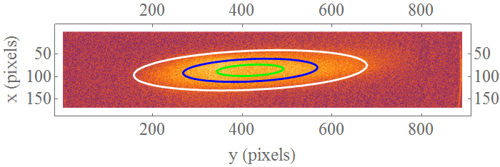

Figure 1: Example proceesed camera image and fitted contour lines.

# Discussion

There is a lot of data to represent, so the results are presented below. Although not relevant for finding the emittance the fitted mean positions are also presented to allow for a comparison between the two methods. The two methods give fairly similar results, but there are differences. For example, tend to have a lower minimum when fitting and fitting tends to give a steeper gradient away from the minimum. The consequence of these differences for the emittance will be considered when fitting to the accelerator model.

There are clear errors in the data, for example saturated images have been found and these explain the features seen, for example, in the covariance of BSOL = 0 for the LHS of Q1, and the RHS of Q2. A typical saturated beam image is shown below, it appears that the saturation distorts the image, effecting the analysis.

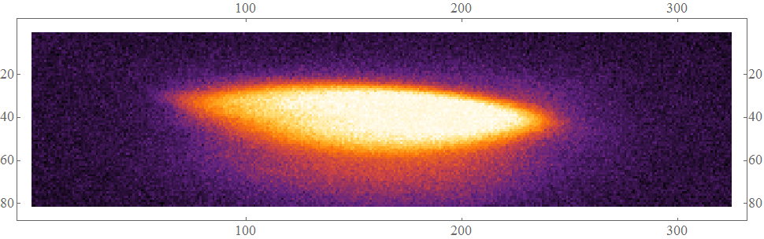

Figure 1: Example saturated camera image.

An interesting feature that regularly shows up in the analysis are the short bumps in the tails such as can be seen in BSOL = -4, Q3. These should be the studied further as it’s not clear if they are result of the analysis, the machine, or the procedure to take the data.

# Results

All the fitted data and matrix components are plotted below for completeness, first mean values with standard deviations as error bars are shown then all the raw numbers. Red points are fits, green points are from the matrix of the data. For the mean positions blue / black are the for the y direction.

## 4.a. Mean and standard deviations values

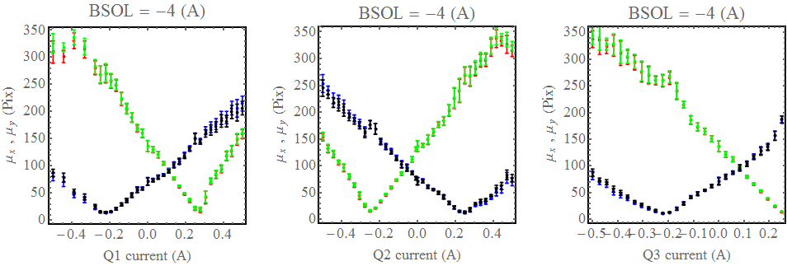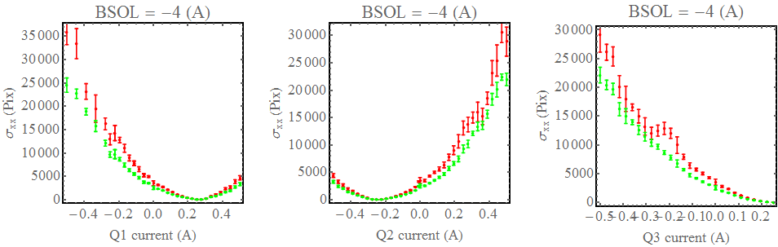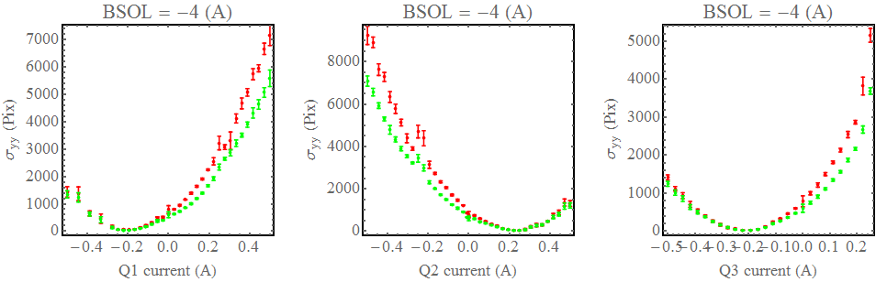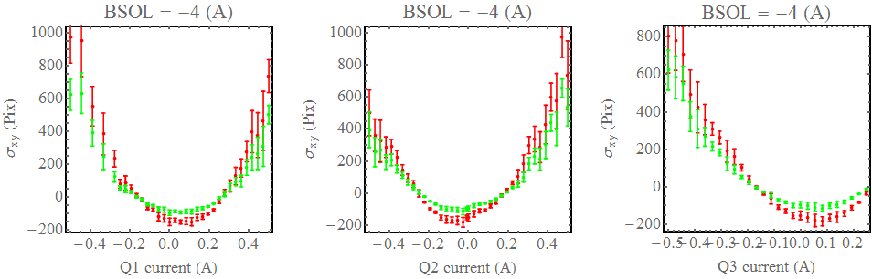

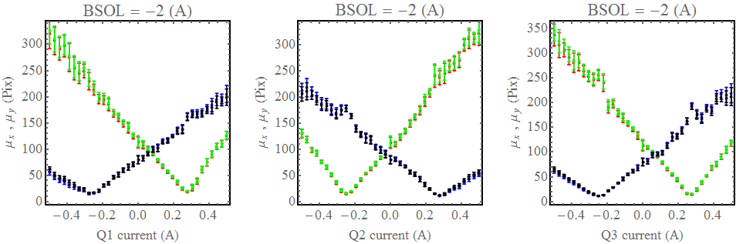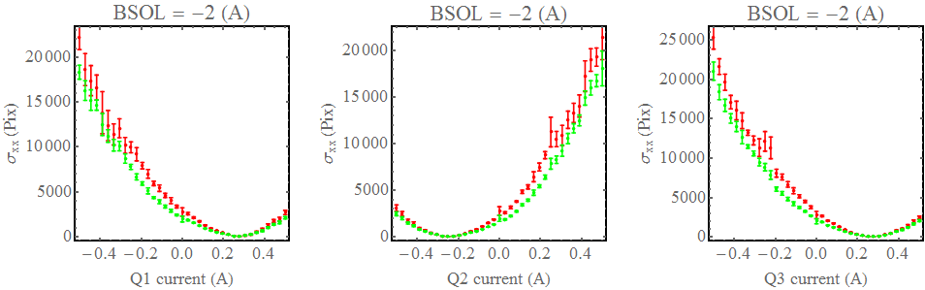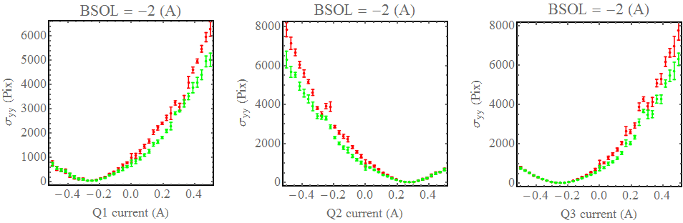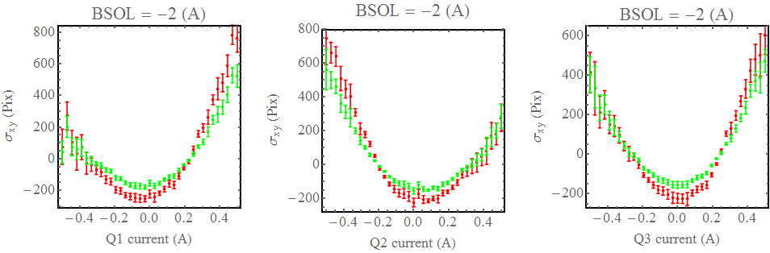

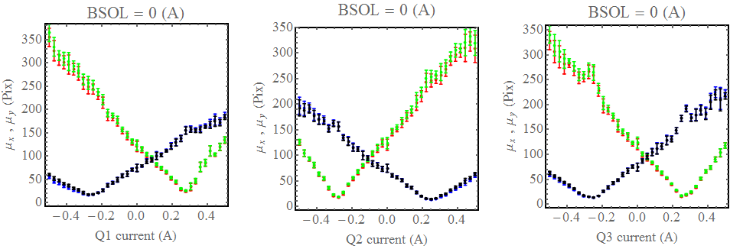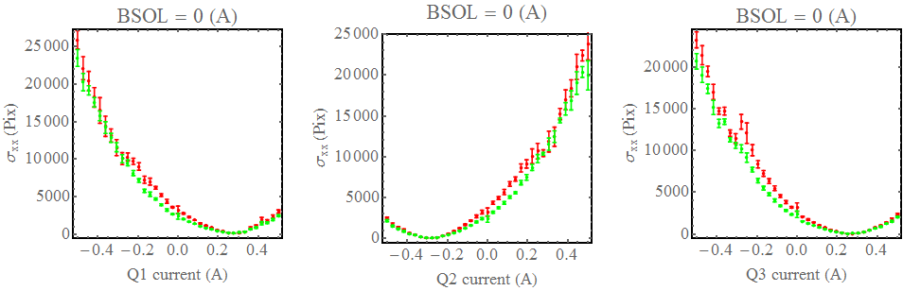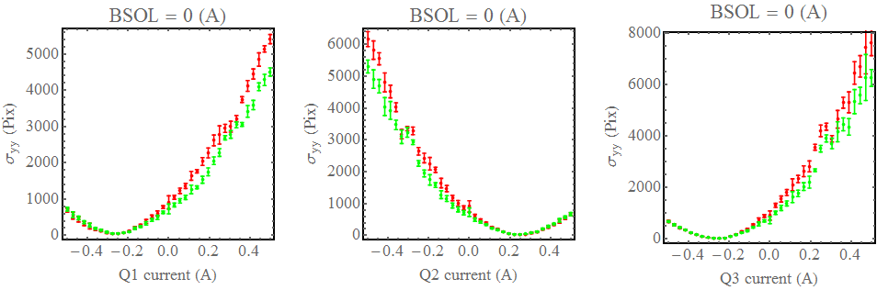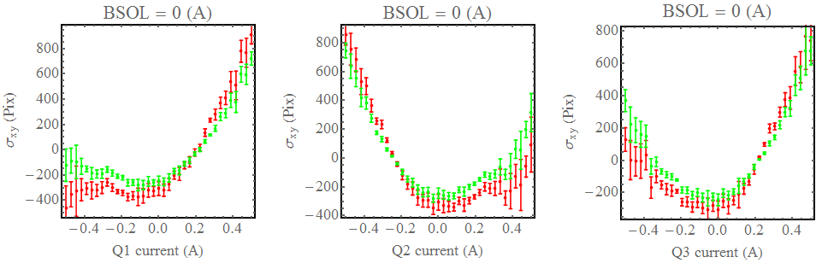

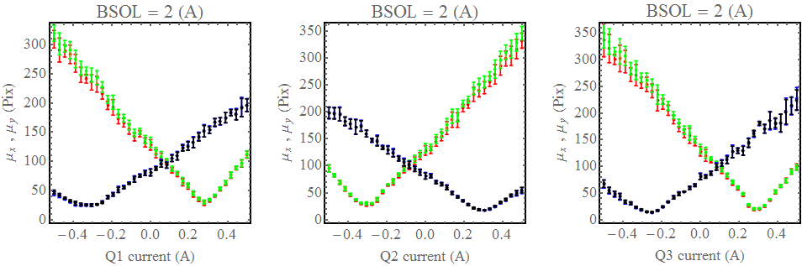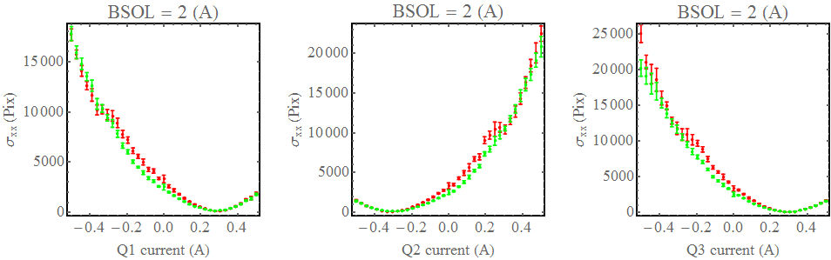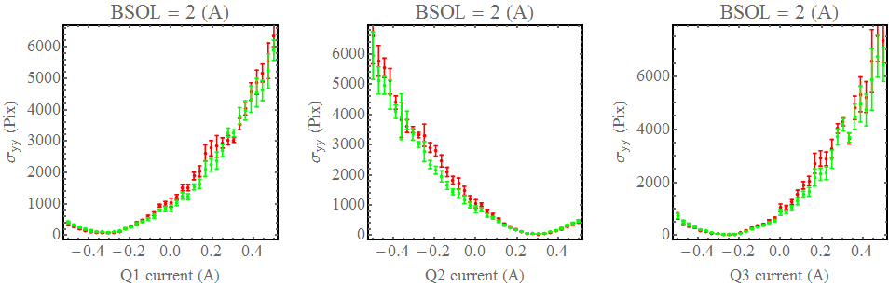

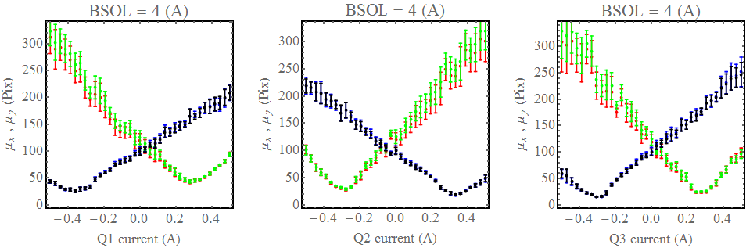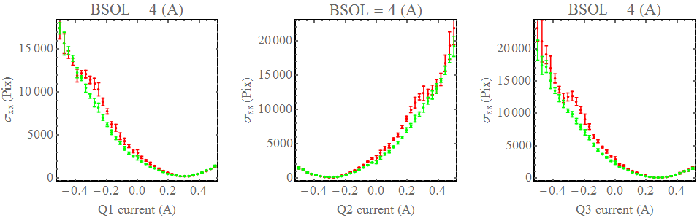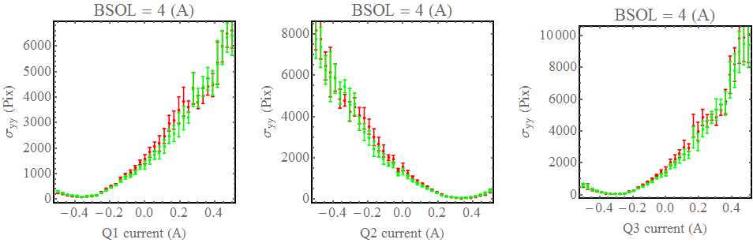

## 4.b. Raw Results

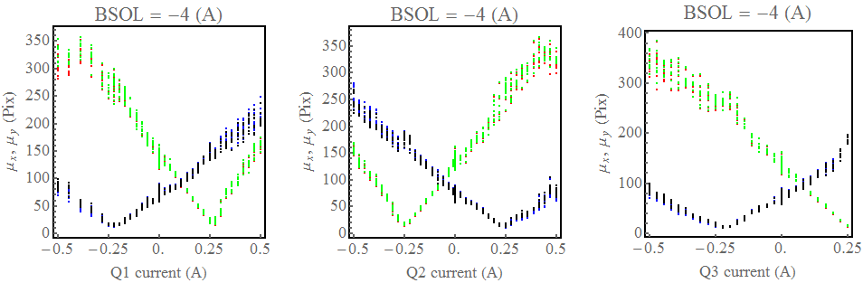

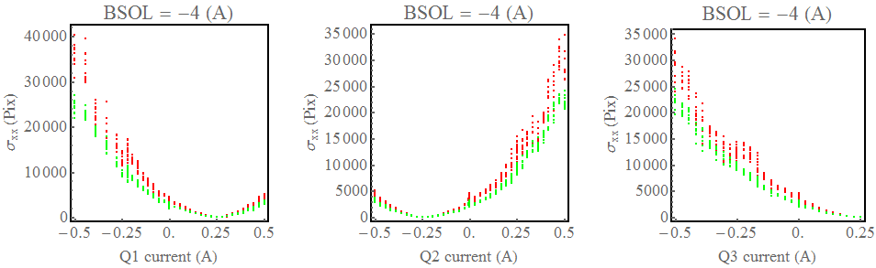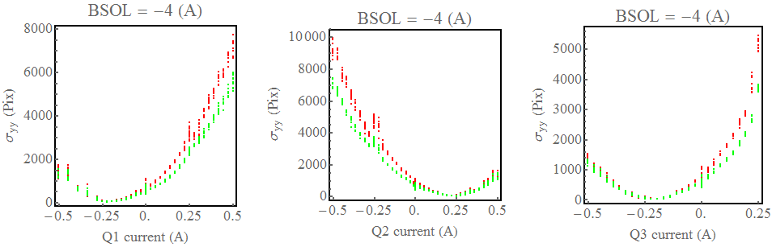

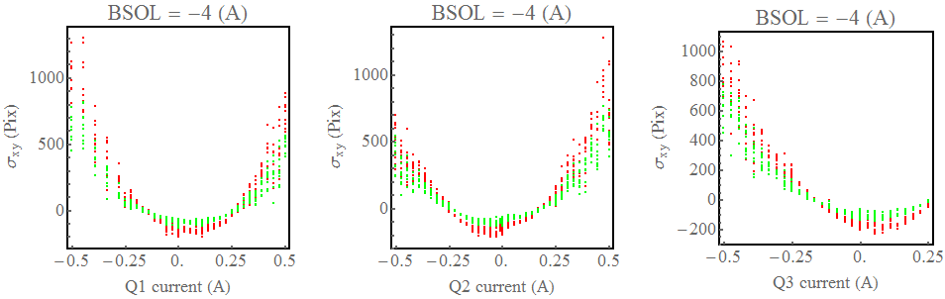

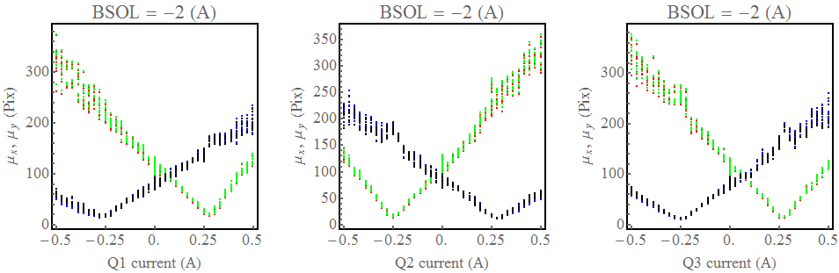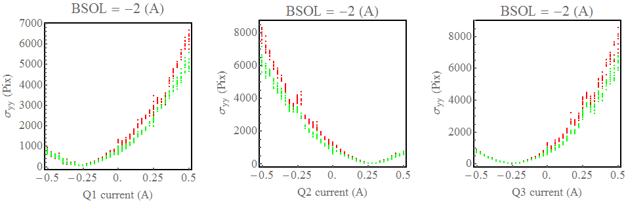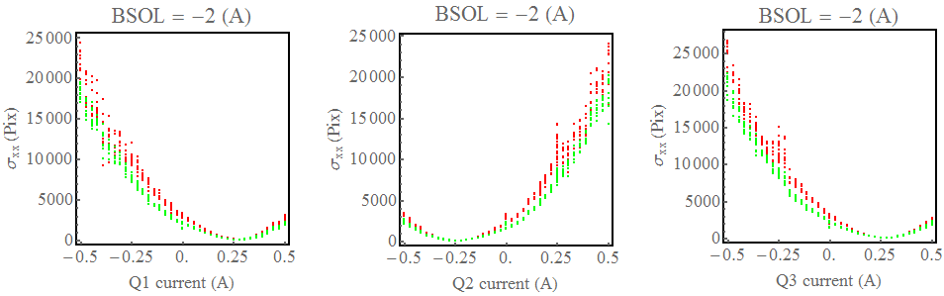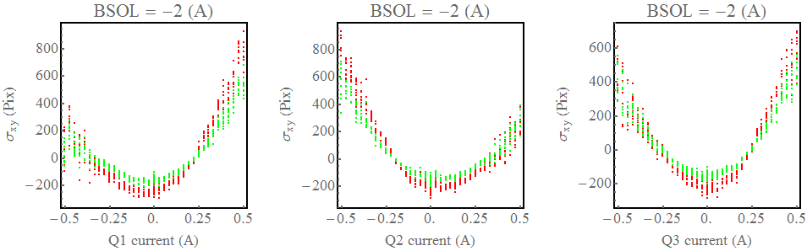

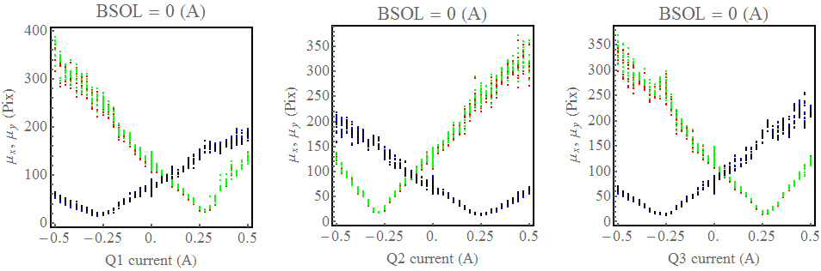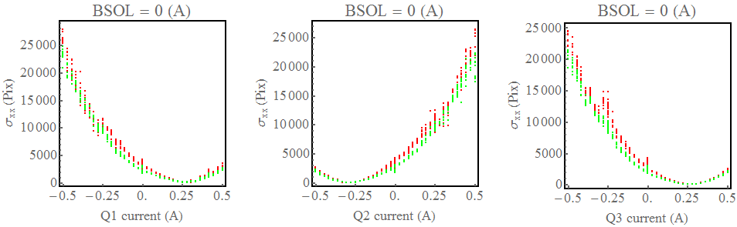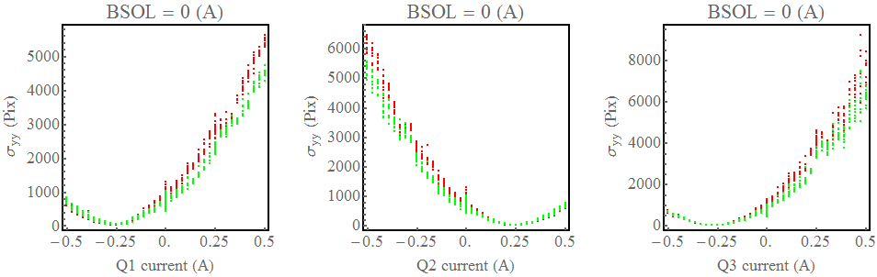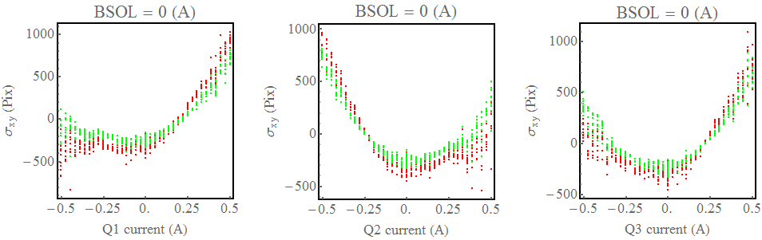

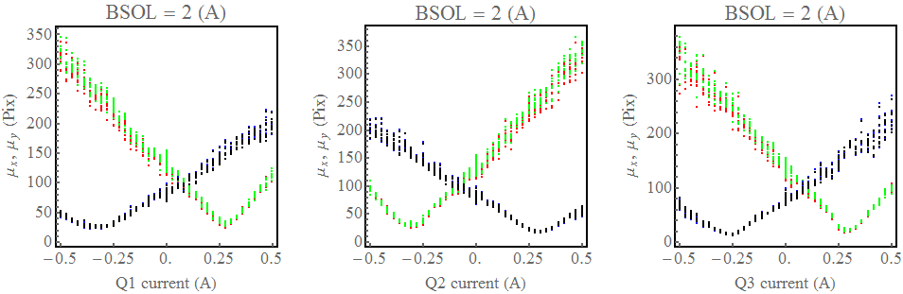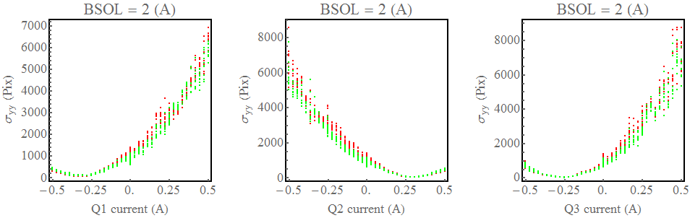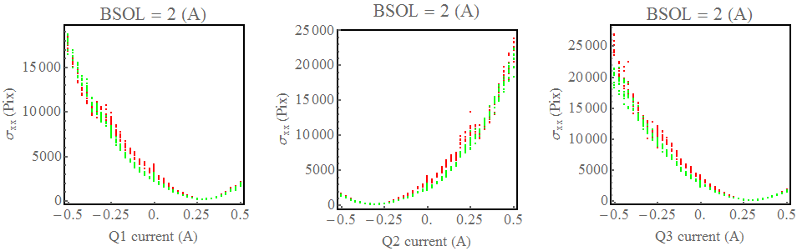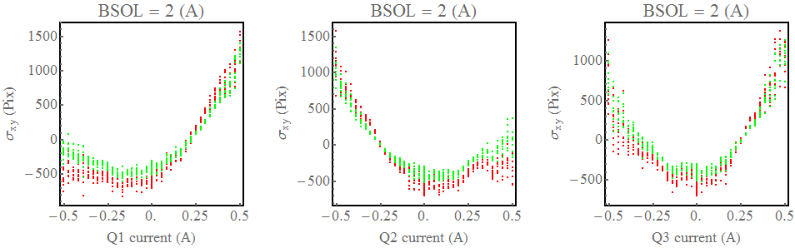

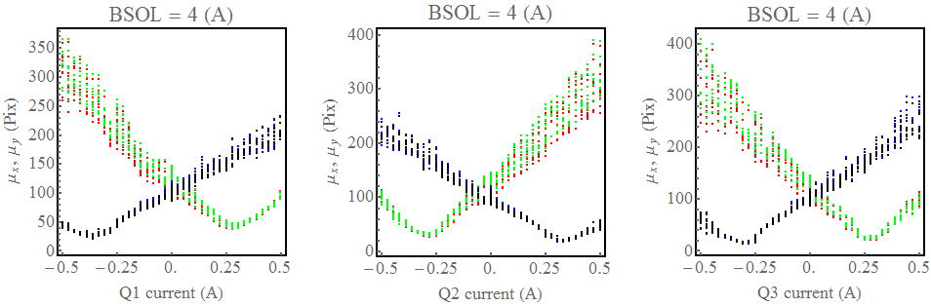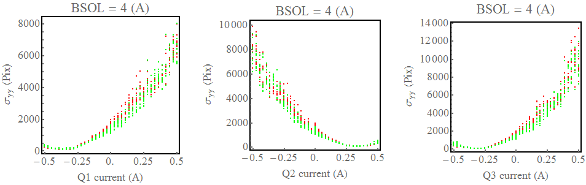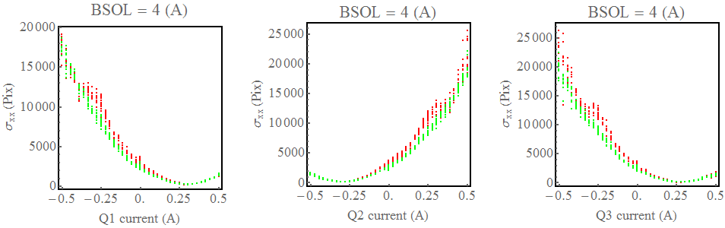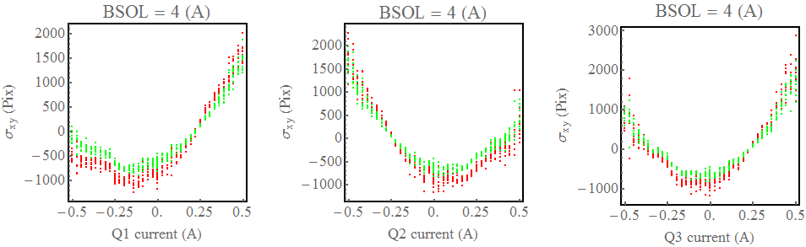

1. *Calculating Beam Sizes From Screen Images on VELA*, Duncan Scott August 2014